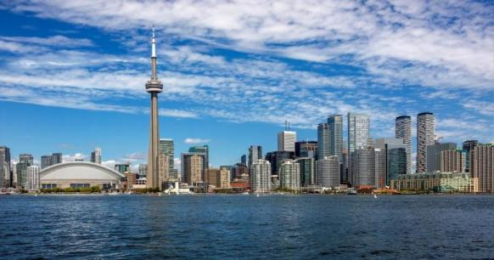

INTERNATIONAL POLICE ASSOCIATION
SECTION CANADA, REGION TWO, TORONTO
-------------------------------------------------------------------------------------

Minutes of Business Meeting
Wednesday, January 10, 2024
York Regional Police, 2 District,
Richmond Hill, Ont.

In Attendance;

*Voting Members (re; money matters)
Farhan Kever, Lino Murarotto, Art Lowe, Les Bodrogi (virtual)
Roger Lowe, Bob Lowe, John McCormack (virtual).

*Absent Voting Members
None.

*Non-Voting Members (re; money matters)
Joe Rizzuti, Keith Chipman (virtual), Jim Dallimore (virtual).

*Absent Non-Voting Members
John Domonkos.

*Visitors
Frank Manchisi, Mike Simone, Dino Cimini,
Mauricio (?Last name), Mo Chong (speaker)

Call To Order;

*Meeting called to order by president Farhan Kever at 1907 hrs.

Approval of December 06/23 Minutes;

*Moved by: Roger Lowe
*Seconded by: Joe Rizzuti & Bob Lowe
*Approved.

Approval of Agenda;

*Moved by: Bob Lowe

*Seconded by: Roger Lowe

*Approved.
,
Membership Secretary’s Report;

*Bob Lowe reports that there is one application pending. Nothing
more at this time.

*R2 has approx. 280 members and the names have been sent to
National, re; member cards. The cards are to be given to the
attending members and the rest will be mailed out.

President’s Report

*Farhan presented P.C. Mo Chong, Crime Prevention Unit,
York of Regional Police. P.C. Chong gave a very informative talk
on the subject of auto theft and how is is becoming far more
active. The talk was well received.

Treasurer’s Report;

*Farhan Kever, acting Treasurer, reports that our bank account
total is $22,957.53

*The closing of the year-end report for 2023, is waiting for the
final statement from the bank. Then the report will be turned
over to John McCormack, treasurer.

Supply Officer’s Report;

*Kieth C.

Travel Director’s Report;

*Jim Dallimore submitted report which is attached.

Events Director’s Report;

*Joe Rizzuti put fourth the pending OACP & Blue Line
convention to be held in Ottawa. He advised that he had
contacted Lou Agostinho of National enquiring as to possible
funding to send some R2 members there. Lou replied for us to
submit a proposal to National ten days, February 02, before
their next meeting. After some discussion, Farhan suggested
that we put it on hold.

Old Business;

*None.

New Business;

*Refer to Events Directors Report.

Adjournment;

*Farhan called an adjournment at 20o5 hrs.

Next Meeting;

*February 07, 2024, at 1900 hrs.

********************************************************************

TRAVEL REPORT IS ATTACHED

